Linux

By Devi Sri Charan

Text and Log File Manipulation 2

Filter Specific Entries 3

Text Substitution 3

Complex Search 4

Extracting Specific Fields 5

Multi-File Text Manipulation 6

# Text and Log File Manipulation

## Filter Specific Entries

**Objective**: Identify and extract entries related to a user named "John". Save the modified log file with "John"'s entries isolated.

**Command**:

grep "John" original_log_file.log > john_entries.log

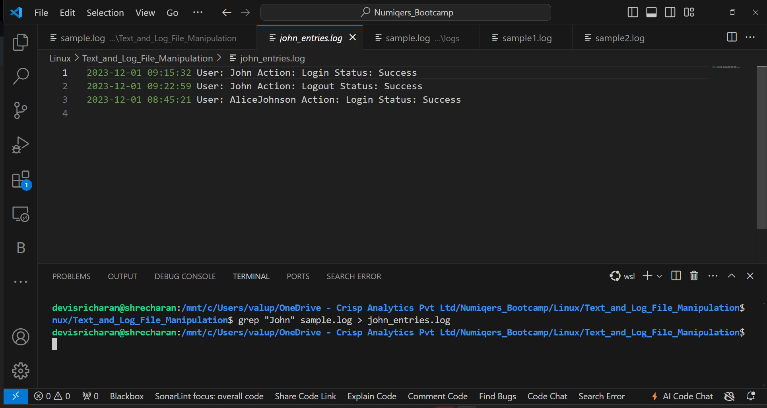

## Text Substitution

**Objective**: Correct typographical errors by replacing "Loogin" with "Login". Make a version of the log file with "Loogin" corrected to "Login".

**Command**:

sed 's/Loogin/Login/g' original_log_file.log > corrected_log_file.log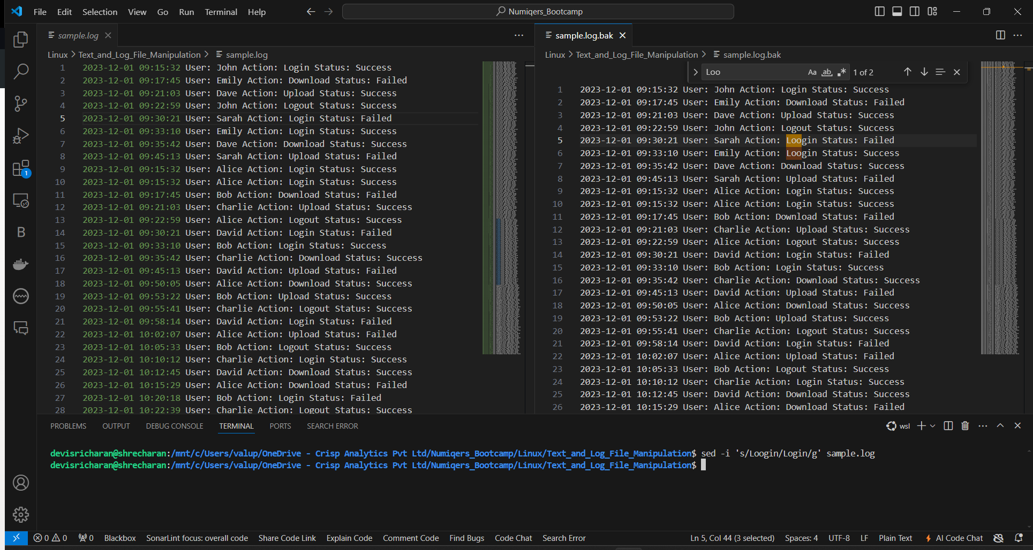

## Complex Search

**Objective**: Locate failed actions and include context by selecting two additional lines surrounding each failed action. Make an extract of the log file showing all "Status: Failed" entries with two lines of context.

**Command**:

grep -B 2 -A 2 "Status: Failed" original_log_file.log > failed_actions_with_context.log

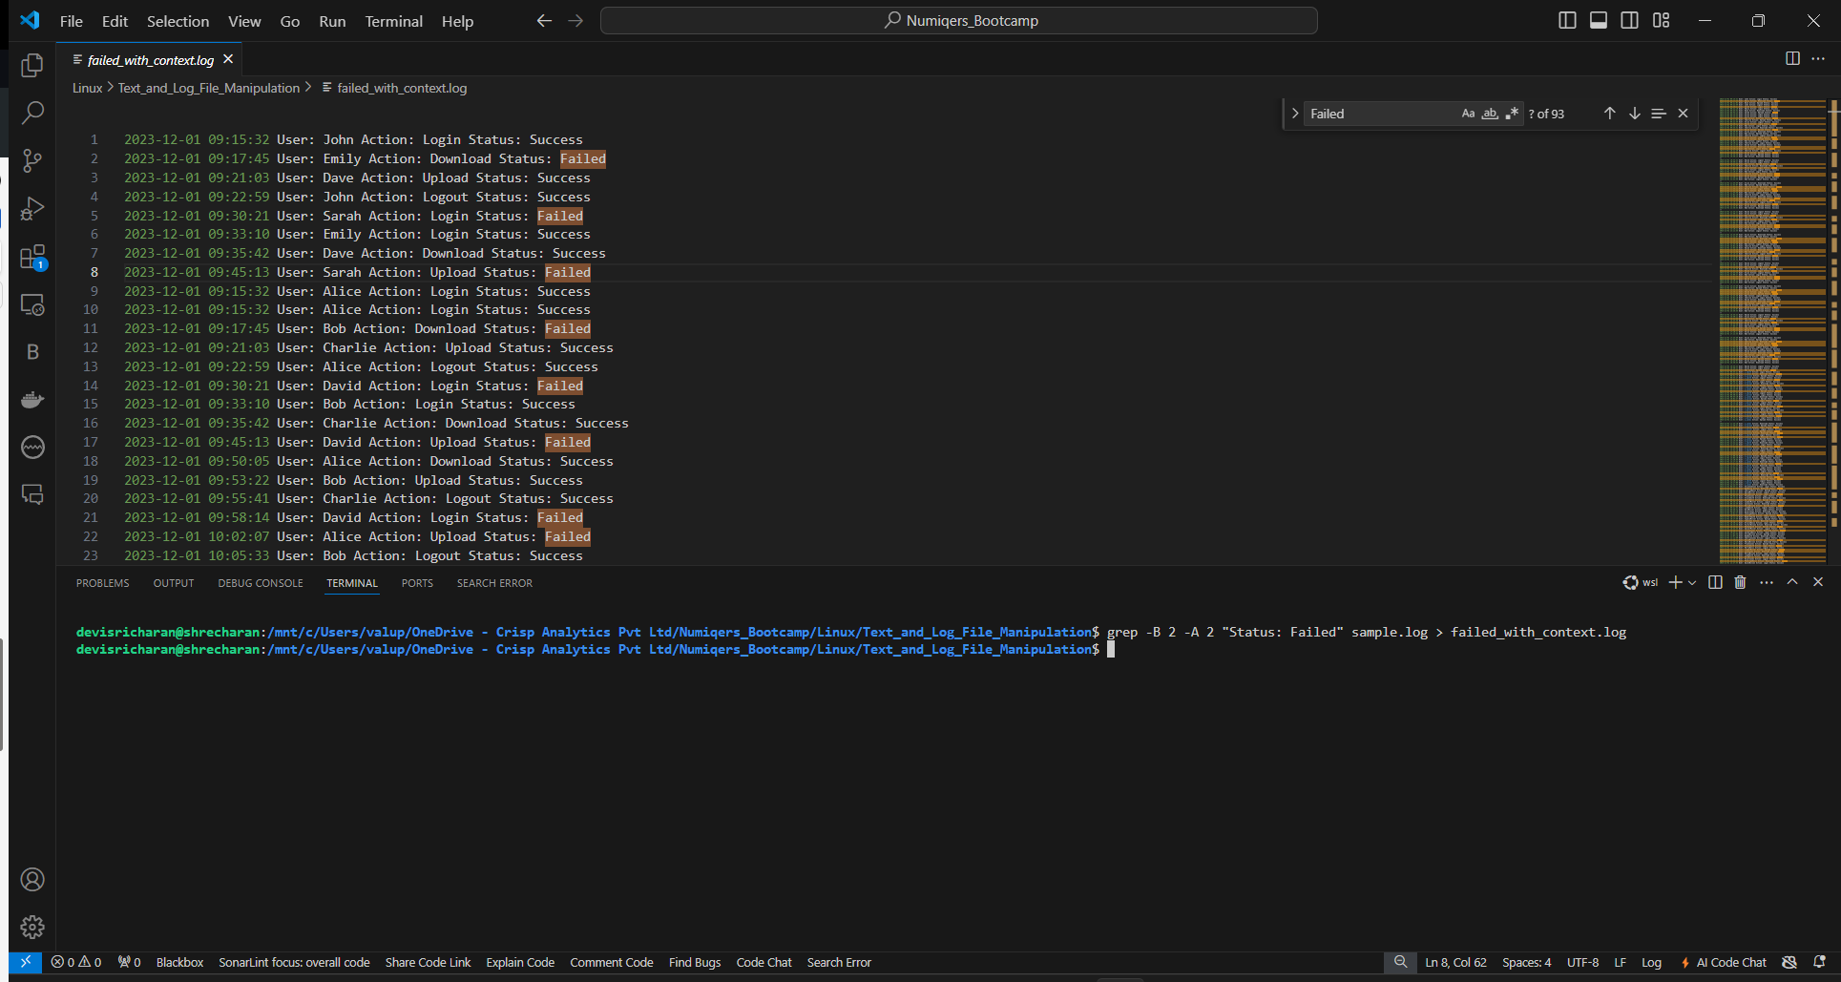

## Extracting Specific Fields

**Objective**: Summarize user activities by listing users and their actions, excluding timestamps and statuses. Make a summary list of all users and actions, formatted as "User: Action".

**Command**:

awk '{print $4 ":" $6}' original_log_file.log > user_activities.log

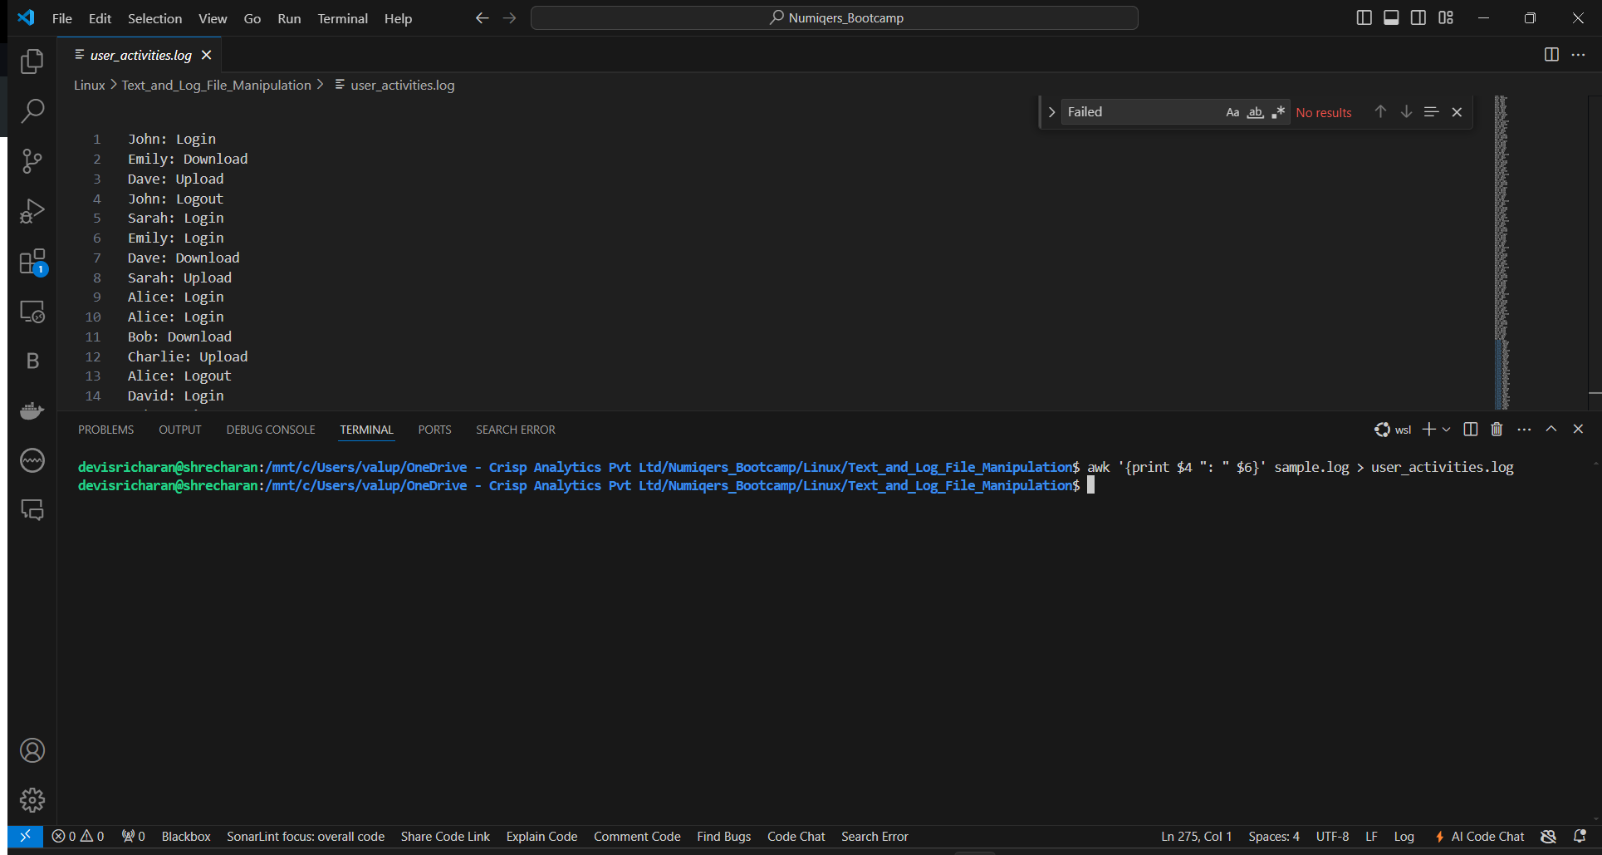

## Multi-File Text Manipulation

**Objective**: Aggregate similar data, specifically failed actions, from a series of log files into a single file. Make a consolidated log file compiling all failed actions from the series of log files.

**Command**:

grep "Status: Failed" log_file1.log log_file2.log log_file3.log > consolidated_failed_actions.log

